NERSC Greenbook Technical Description
Stellarator Design and Physics
D. A. Spong (spongda@ornl.gov) - ORNL

Overview

Stellarators are three-dimensional toroidal plasma confinement devices that rely on a numerically determined plasma surface shape in order to achieve optimized plasma confinement, stability and steady state operation. Stellarator physics and simulation is of increasing interest in the U.S. Fusion program both due to the possibility that new compact [see Figs. 1(a) and (b)] experimental facilities will be sited at several U.S. research centers. Interest is also driven by the existence of a large ($1 billion class) experimental stellarator facility in operation now in Japan [LHD - Fig. 1(c)] and a second one under construction in Europe [W7-X - Fig. 1(d)]. These devices have the potential of supplanting the tokamak as a path to the development of fusion power. Due to their inherently three-dimensional nature, stellarators rely heavily on numerical simulation and computation. The optimized design and physics analysis of these devices would not be possible without high performance computing.

(a) (b)
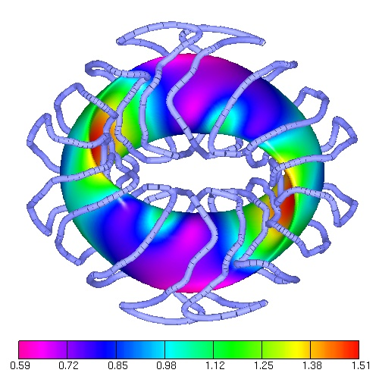 | 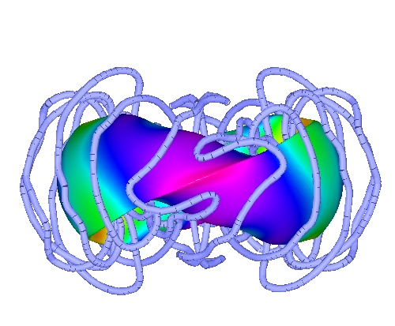
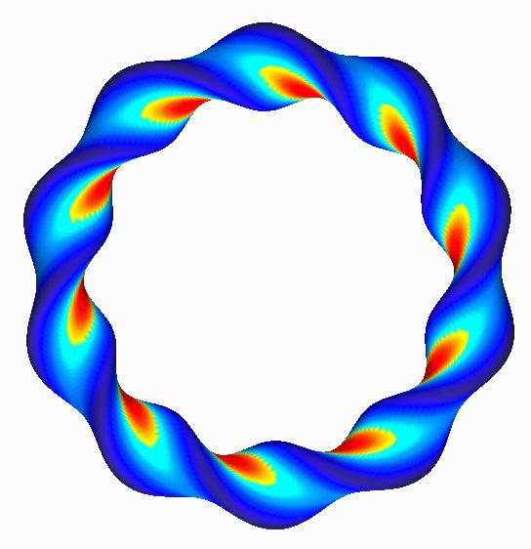 | 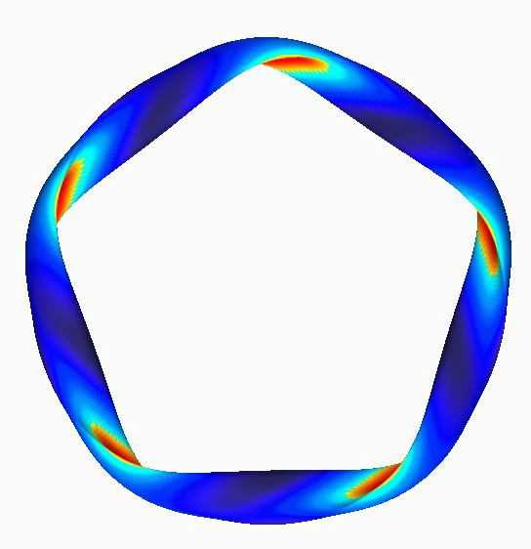
- (d)
Figure 1 - (a), (b) Top and side views of QOS compact stellarator magnetic flux surfaces and filamentary magnet coils (color contours show magnetic fiield strength (in Tesla), top views of (c) LHD and (d) W7–X magnetic flux surfaces.

Plasma Equilibrium, Reconstruction, and Optimization

Calculation of the plasma equilibrium is the fundamental starting point for all other physics and optimization studies of the stellarator. In general, mathematically smoothly varying equilibria do not exist for three-dimensional configurations and some degree of magnetic island formation will always be present. In some cases this can be neglected, as is done in the VMEC code, but in general it must be taken into account (e.g. as in the PIES, HINT, and NSTAB codes), especially for understanding plasma edge transport and nonlinear MHD instability phenomena. This characteristic of stellarator equilibria is expected to demand high numerical resolution and needs for large amounts of memory.

Two of the more numerically intensive uses for stellarator equilibrium codes are in the reconstruction of experimental equilibrium characteristics from magnetic measurements external to the plasma and in the optimized design of new stellarator experimental devices. Both of these calculations involve a nonlinear root finding/optimization loop external to the equilibrium code. This loop typically varies the plasma shape and profiles of some of the internal plasma physics parameters in order to minimize a χ² function (either the physics properties of an optimized design or the goodness of fit to experimental data). A Levenberg-Marquardt algorithm has been used for this minimization process; this has recently been adapted to parallel architectures by using a bank–queueing model with MPI language calls for interprocessor communication. These calculations involve moderate levels of communication between processors and would benefit from a tightly coupled processor architecture.

Plasma Confinement

Plasma confinement in stellarators includes transport both of the thermal plasma component as well as various energetic tail components which are utilized for plasma heating. Although transport of the thermal component may in many cases be dominated by anomalous losses from microturbulence, it is desirable to accurately evaluate the neoclassical component in order to understand enhanced confinement regimes (where the microturbulence is suppressed) and transport properties parallel to the magnetic field lines (which are not as influenced by microturbulence as is the perpendicular transport). Due to the three-dimensional nature of stellarators, the calculation of classical transport rates is a much more non-trivial problem that it has been in the case of axisymmetric tokamaks. To address this need, we have developed the drift-kinetic solver (DKES) code that currently solves for the plasma distribution function in two spatial dimensions and one velocity dimension. However, to better address the physics of particle drifts at low collisionality, this code will be extended first to 4 dimensions (three spatial and one velocity) and eventually 5 dimensions (three spatial and two velocity). The current code utilizes OpenMP parallelization on a single SMP node. We envision the 4D and 5D models as mappings of the current 3D model across multiple SMP nodes; i.e., each node will contain a diagonal block matrix that looks like a separate 3D model. This calculation will benefit from very dense nodes of tightly coupled processors.

The alternative approach to these direct solutions of the drift kinetic equation is in the Monte Carlo or particle simulation approach. This method is expected to remain of interest particularly for relatively collisionless energetic tail populations used in heating, such as neutral beams, RF produced tails and alpha particles from the DT fusion reaction. Most Monte Carlo calculations to date have been nearly trivially parallel; both parallelization over particle groups (DELTA5D code) and over domains (GTC code) have been used based on MPI calls. However, as higher degrees of self-consistency are incorporated into these models, greater degrees of interprocessor communication will be necessary throughout the calculation. Therefore, it expected these models also should work best on very dense nodes of tightly coupled processors.

Plasma Heating

The primary methods of plasma heating for stellarators consist of RF (radio-frequency), neutral beams, and, in reactors, alpha populations. The latter two methods are probably best addressed with Monte Carlo techniques or direct solution of the plasma kinetic equation, as described above. RF heating requires the solution of the electromagnetic wave propagation equations, self-consistently coupled with the plasma kinetic response to these waves. RF theory and simulation have been developed over a number of years for tokamaks and have yielded many important insights not only for efficient methods of heating, but also for current drive (needed for steady state operation) and flow drive (needed for turbulence suppression) techniques. Initial experimental results and modeling of ion cyclotron RF heating on the LHD stellarator in Japan have indicated a number of anomalies (e.g., centrally peaked electron absorption) that cannot be explained by the 2D RF absorption models which have been applied. It is clear that developing an adequate understanding of the science of RF heating in stellarator devices will require building new 3D models. Adapting RF theory to stellarators will introduce major new computational challenges. These calculations generally lead to large dense linear systems and will require large amounts of memory and dense tightly coupled processors.

Plasma Stability and Turbulence

This topic includes both large scale resistive and kinetically driven MHD instabilities as well as the smaller scale microturbulence that drives anomalous transport in magnetically confined plasmas. With the anticipated advent of new stellarator experiments in this country, it is expected that activity in this area will increase; however, current work in this area is still at an embryonic stage. Nonlinear MHD analysis will become of more importance after stellarator experiments have been in operation for several years and begin to push at the limits of plasma pressure and current density. Kinetic MHD is of importance in high temperature regimes of operation and in extrapolation to fusion reactor configurations. Microturbulence modeling will be of importance in understanding plasma transport in all regimes of operation. The impact of understanding stellarator microturbulence is that it can lead to turbulence suppression techniques; this can ultimately lead to smaller, more economical fusion reactors. These topics have been developed to a high degree of sophistication for axisymmetric tokamaks and it would be expected that much of this work could be adapted to three-dimensional stellarator configurations, albeit with much greater computational performance challenges. The MHD calculations typically involve the inversion and time-stepping of large sparse linear systems. These codes generally have difficulty maintaining linear speed improvements when parallelized over increasing numbers of highly distributed processors; however, they should benefit from tightly coupled dense nodes of processors. They also tend to have large memory needs per processor when run at their highest resolutions.

The types of computational models used to study microturbulence generally use either particle simulation techniques (δf gyrokinetic models) or more fluidlike techniques (gyrofluid models); the former codes may be expected to share similar computing needs with the Monte Carlo calculations described above. The latter codes will be more similar in their needs to the nonlinear MHD models as described in the above paragraph.

