Simulation of Microturbulence in Magnetic Fusion Experiments

One of the fundamental grand challenge problems in magnetic fusion energy research is the understanding and control of turbulent transport of energy observed in the core of many fusion experiments. Drift-wave turbulence has been identified experimentally as a primary mechanism in degrading energy confinement in tokamak core plasmas. For some years there has been a large effort in the fusion community to simulate drift-wave.¹ This simulation activity has lead to a suite of three-dimensional, toroidal simulation codes that have been used by a national collaboration (first under the auspices of the Numerical Tokamak Turbulence Project and subsequently as the Plasma Microturbulence Project). These models have been extensively benchmarked against independent linear calculations of the basic underlying microinstabilities and nonlinearly against one another to obtain results for the nonlinear saturation of drift-type instabilities in current experiments, e.g., Princeton’s TFTR and General Atomics DIII-D. The simulation results have been used to calibrate reduced models of the turbulent transport and to derive scaling relations for use in comparing and predicting experimental results with increasing success. Specific features associated with the moderation of the turbulent transport by means of externally imposed and self-generated velocity shear have been illustrated and demonstrated with the simulations. The elucidation of the physics of shear-flow inhibition by simulation and theory, and its confirmation in experiments exhibiting internal transport barriers have led to major advances in producing tokamak plasmas with improved energy confinement in a more predictable and repeatable fashion.

Three related models have been used, all of which solve for the self-consistent electric or electromagnetic fields and the associated nonlinear plasma response. The three models solve the coupled Maxwell and Vlasov equations for plasmas supporting drift-type microinstabilities in three spatial dimensions and two velocity-space variables (the third velocity-space variable, the gyrophase angle in the applied magnetic field, has been analytically removed by gyro-averaging the equations). The three models are gyrokinetic particle codes (Lagrangian description), gyrofluid codes with Landau closure, and gyrokinetic continuum codes (Eulerian description). All three models have been parallelized and run on the NERSC T3E and other massively parallel platforms. By developing and applying three different approaches to microturbulence simulation, the magnetic fusion community has been able to carefully explore the oomparative computational efficiencies of the three approaches and perform important code cross-checks on the nonlinear simulations (which has been essential for debugging the codes and determining the reliability of the physics results²). Because the three approaches differ significantly in their algorithms, their diversity also has been useful for understanding how to optimize code efficiency for the specific architecture of the host supercomputer with benefits ensuing to other scientific disciplines faced with similar computational challenges.

We have been very successful in developing codes for modeling plasma turbulence for which computer run-time and problem size scale well with the number of processors on massively parallel machines (Fig. 1).³ We have experience in being able to make successful use of new platforms at NERSC and to fully utilize NERSC resources. To date our simulations have been limited by computing resources that constrain us to simulate experiments with either smaller plasmas or plasmas with less than the optimal spatial resolution, or to undertake fewer simulations and limit parameter studies, or to target an annular region of a tokamak experiment albeit with realistic parameters (Fig. 2), whose computational requirements are generally less stringent than those for a full global simulation (although we also routinely undertake global simulations, Fig. 3). Another important limitation on research progress due to limited computer resources has been the turnaround time for a researcher to be able to undertake a series of simulations addressing a parameter scan, which profoundly impacts the pace of physics progress. Thus, upgrades at NERSC addressing both capability and capacity simultaneously are vital to taking the next steps in increasingly realistic physical simulations in magnetic fusion research on microturbulence and in all disciplines of programmatic interest to DOE. To illustrate this, we consider a full-device particle simulation of a next-step tokamak capable of achieving ignition or high fusion gain. Such a device would have a minor radius of the order of 103 times ρi (the ion Larmor radius). Using a magnetic field-aligned co-ordinate system, a full-device simulation of ITG turbulence, including wavelengths down to the ρi scale, would require a grid with NRadial≈ 1000, NPoloidal ≈ 3000, and N|| ≈ 64 for a total of about 2×108 grid points. Our experience indicates that 16 particles/grid cell (for a total of 3.2×109 particles) is adequate to provide a long interval of fully developed turbulence without excessive discrete particle noise. About 50,000 time steps will be required to simulate 100 turbulent decorrelation times. Scaling from our experience on the T3E (a 0.5 TFlop machine) we find that a 10 TFlop computer can be expected to achieve a speed of 2×10-9 sec/particle/time-step. Hence, a full-device simulation of ITG turbulence in an ignition experiment will take about 90 hours on a 10 TFlop computer. Presently, our codes require about 0.3kbytes of memory/particle. However, the larger grid required for these simulations will may require domain-decomposition in 2 or 3 dimensions (presently we only decompose in 1-D), leading to somewhat larger memory requirements/particle. Taking a conservative estimate of 1 kbyte/particle, we conclude that we this simulation would require about 3 Tbytes of RAM distributed among the processors. The disk storage requirements, which are dominated by restart dumps, would be about 100 times the memory size, or 300 Tbytes.

We conclude that full-device simulations of ITG turbulence in an ignition-scale magnetic fusion device is an ambitious, but achievable on a 10 TFlop computer. Such simulations would allow detailed investigation of scientific questions regarding the role of meso scales in ITG turbulence, the dynamics of spectral transport, and the formation and evolution of transport barriers. The 10 Tflop computer will also make easier the inclusion of the more complete and better physics models that we have developed that include, for example, kinetic electron effects and electromagnetic coupling of the drift waves to kinetic shear-Alfven waves that modify the microinstabilities in the plasma at finite plasma pressures.
1. B.I. Cohen, D. C. Barnes, J. M. Dawson, et al Comp. Phys. Commun. 87, 1 (1995).
2. A.M. Dimits, G. Bateman, M.A. Beer, B.I. Cohen, et al., Phys. Plasmas 7, 969 (1999).
3. Z. Lin, T.S. Hahm, W.W. Lee, W.M. Tang, and R.B. White, Science 281, 1835 (Sept. 1998); A.M. Dimits, T.J. Williams, J.A. Byers, and B.I. Cohen, Phys. Rev. Lett. 77, 71, (1996); J. Kepner, S. Parker and V. Decyk, SIAM News 30, 1 (1997); R. E. Waltz, G.M. Staebler, W. Dorland, G.W. Hammett, M. Kotschenreuther, and J.A. Konings, Phys. Plasmas 4, 2482 (1997).

Figure 1. Scaling of massively parallel code performance of the GTC global gyrokinetic particle code. (Z. Lin, Princeton U.)

Figure 2. Flux-tube gyrokinetic simulation of ion-temperature-gradient drift-wave microturbulence. Contours of density fluctuations. (Dimits, Williams, Shumaker, Cohen, and Nevins, LLNL)

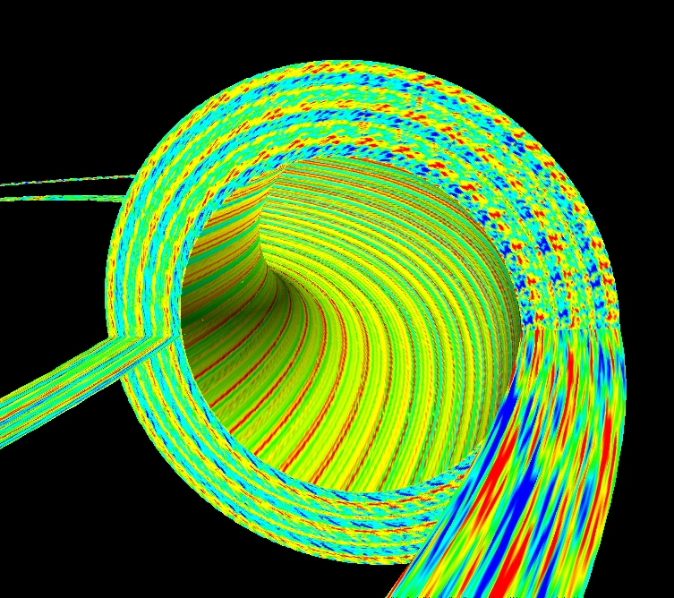

Figure 3. Global simulation of ion-temperature-gradient turbulence in a tokamak showing the influence of sheared flow on moderating the turbulence. Contours of density fluctuations .(Z. Lin, T.S. Hahm, W.W. Lee, W.M. Tang, and R.B. White. Princeton U.)

Figure 4. Global simulation of ion-temperature-gradient turbulence modeling the DIII-D tokamak. Contours of density fluctuations (J.-N. Leboeuf, UCLA; R. Sydora, U. Alberta)
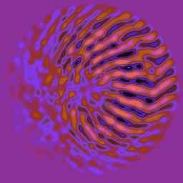
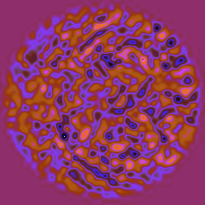
Linear Phase
Nonlinear
Steady State

